16.18: (a) The sound level is
b) First find v, the speed of sound at 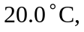 from Table 16.1, 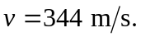
The density of air at that temperature is 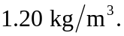 Using Equation (16.14), 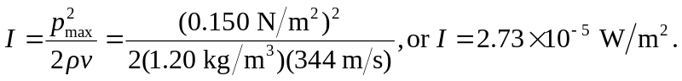 Using this in Equation (16.15), 